Long run production
- Circular flow
- Long run model of production = closed economy, composite good, markets clear
  - Labour L and capital K to form Y given productivity parameter A
  - K and L are in fixed supply (with a bar)
- MPL = F (K, L + 1) – F (K, L). MPK = F (K + 1, L) – F (K, L)
- Neoclassical production function assumes constant returns to scale via replication argument
  - Know how to show CRS, IRS and DRS
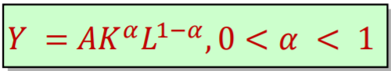
  - Cobb-Douglas production function:

- Also assumes diminishing marginal returns (returns to fixed factor)
FoP Markets
- Supply is fixed
- Demand determined by firm behaviour. Assume perfect competition so firms are pricrtakes who maximise profits
  - Firms hire K and L until change in profit = 0
  - P x MPL – W = change in profit
    - At profit max, P X MPL = W so MPL = W / P
  - P X MPK – R = change in profit
    - At profit max, P X MPK = R so MPK = R / P
Solving the model
- The model has five endogenous variables: Output (Y), the amount of capital (K), the amount of labour (L), the real wage (W/P), the real rental rate of capital (R/P)
- The model has five equations: the production function, the rule for hiring capital, the rule for hiring labour, supply equals the demand for capital, supply equals the demand for labour
Equilibrium
- General equilibrium – model’s solution where multiple markets clear e.g. labour, capital and the aggregate economy
- Labour clears as the real wage adjusts to equate labour demand (MPL) to supply (fixed)
- Capital clears as the real rental rate adjusts to equate capital demand (MPK) to supply (fixed)

Long run demand

National income equation / components of AD
GDP: Y = C + I + G + (X-M)
- Consumption (C) accounts for over 60% of GDP. It refers to the goods and services purchased by consumers.
- Investment (I), sometimes called fixed investment, is the purchase of capital goods that are not consumed right away. It is the sum of non-residential investment by firms and residential investment by consumers. Accounts for around 10% of GDP.
- Government Spending (G) refers to the purchases of goods and services by all levels of government. It does not include government transfers, nor interest payments on the government debt.
- Net exports (X-M) are the purchases of UK goods and services by foreigners less the purchases of foreign goods and services by consumers, business firms, and the UK government. Also known as the trade balance.

Assumptions
- Closed economy so NX = O
- National income = total output supplied
- To study demand side, we keep output fixed

Consumption

Determinants of Consumption
- Understanding the determinants of consumption is important because it is the main driver of GDP, so we may desire to manipulate it in order to affect GDP.
- Disposable income (Y_{D}), the most significant determinant of consumption, is wthat remains once consumers have paid taxes and received transfers from the government. Algebraically:
C = C(Y_{D}), where Y_{D} ≡ Y − T
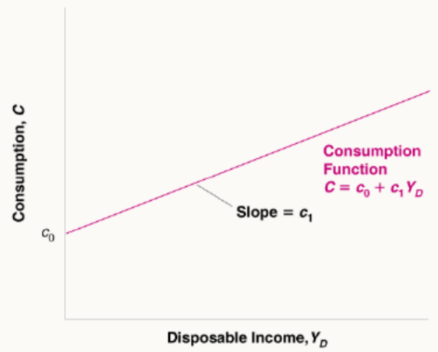
- The function C(Y_{D}) is called the consumption function. It is a behavioural equation – it captures the behaviour of consumers. A more specific form of the consumption function is this linear relation:
C = c₀ + c₁Y_{D}

The Consumption Function
- c₁ is the marginal propensity to consume (MPC); this is the gradient of the consumption curve in the Keynesian cross. C₁ is around 0.7 in the UK, and is almost always between 0 and 1 in the long run.
- c₀ is the intercept of the consumption function. It shows consumption if disposable income were zero i.e. autonomous consumption through dissaving. Autonomous spending is only independent of our income in the short run. A shift in c₀, the intercept, represents a change in consumption for a given level of disposable income (e.g. due to changes in consumer confidence)

Investment
- Investment is the aggregate of all purchases which increase the capital stock of firms and households. The investment function I = I(r) shows us that investment, I, is a decreasing function of the real interest rate, r.
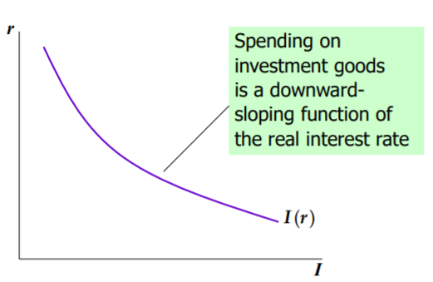
- The real interest rate is the cost of borrowing and the opportunity cost of using your funds to finance investment spending, as opposed to collecting interest in a bank account

Government spending
- Government spending on goods and services, excluding transfer payments
  - Current vs non-current spending
- We assume government spending and total taxes are exogenous and fixed, but in reality things like consumption would affect tax revenues.
- Relationship between G and T shows us the budget surplus / deficit

Goods market equilibrium
IR equates income with output
- Aggregate demand: Z $≡$ C + I + G
  - In a closed economy AD is the sum of consumption, investment, and G.
  - Using the recently explored consumption and investment functions, we see that:
    - Z = c₀ + c₁(Y-T) + I(r)+ G
- Aggregate supply: Y = F (K,L)
- Equilibrium in the goods market requires that production (Y) be equal to the demand for goods (Z). Substituting in the previous equation we get:
  - Y = c₀ + c₁(Y-T) + I(r) + G
  - The real interest rate adjusts to equate demanded income with supplied output
- Expanding the equilibrium equation, we can obtain:
  - Y = c₀ + c₁Y – c₁T + Ī + G
  - Rearranging this to see that:
  - (1-c₁) Y = c₀ – c₁T + Ī + G
  - Y = $\frac{1}{1-c1}$(c₀ – c₁T + Ī + G)

Autonomous Spending and The Multiplier
- The equilibrium equation allows us to visualise two important concepts:
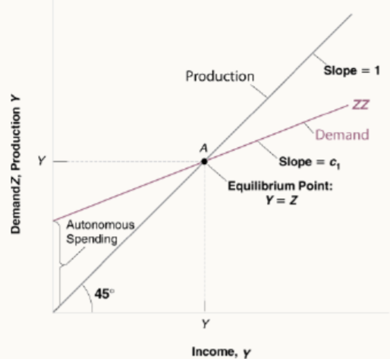
- Autonomous spending: the part of the demand for goods that does not depend on output
- The multiplier: the propensity to consume (c₁) is between zero and one and so the multiplier, $\frac{1}{1-c1}$, is greater than one.
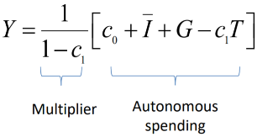

Your estimation of the multiplier determines how much government spending you will advocate for. Further, the larger MPC (c₁), the larger the multiplier.

Loanable funds market
- Demand for loanable funds is investment I(r)
  - Firms borrow to finance spending on new equipment, building etc
  - Consumers borrow to finance residential investment through mortgages
- Supply of funds comes from saving
  - Households save through bank deposits which become available to firms to finance investment spending, through the banking system. This is private saving
  - Public saving exists where G > T.
- Price of funds is real interest rate
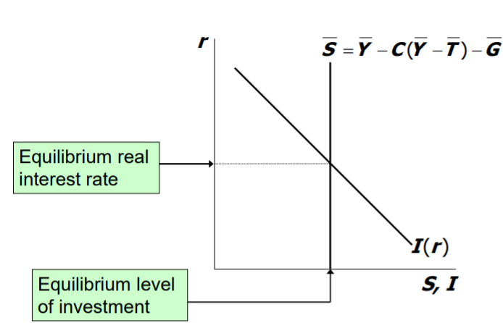
  - A higher real interest rate will decrease investment

Types of saving
- Private saving: (Y – T) – C
- Public saving: T – G
- National saving: Y – C – G

Equilibrium
- National saving assumed to not depend on r, so the supply curve is vertical
- r has a special role as it adjusts to equate the goods market and loanable funds market simultaneously
  - When the loanable funds market is in equilibrium, national saving equals national investment so Y – C – G = I(r)
  - When the goods market is in equilibrium, Y = C(Y – T) + I(r) + G

Comparative statics
- Changing exogenous variables shifts the curves.
- Increasing G reduces national saving (supply of loanable funds), thus raising the real interest rate, thus reducing investment levels
- Decreasing T increases consumption as (Y – T) increases. This decreases total saving, thus raising the interest rate and reducing investment

